### AI ASSISTED CODING

### ASSIGNMENT-1

### NAME : YUVARAJ REGULA

**BATCH : AIML-14**

**HALL.NO: 2403A52386**

**01.PROMPT :**

i need python code ,which checks the the given string is pandrome or not , if yes print "its a palindrome " if no print "its not a palindrome" and ignore the spaces and case

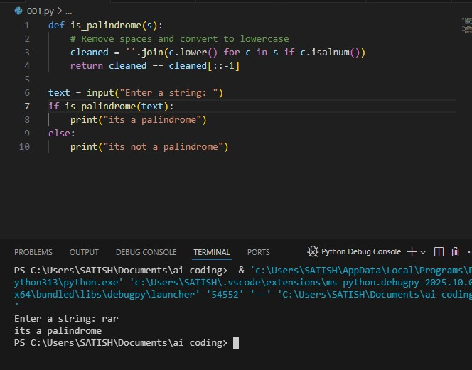**CODE AND OUTPUT :**

CODE EXPLANATION :

This Python code checks if a given string is a palindrome (reads the same forward and backward):

cleaned = ''.join(c.lower() for c in s if c.isalnum())  
➤ Removes spaces/punctuation and converts letters to lowercase.

* cleaned == cleaned[::-1]  
  ➤ Compares the cleaned string with its reverse.

If equal, it prints "it's a palindrome", otherwise "it's not a palindrome".

**02.PROMPT :**

generate a python code , function that returns the fibonacci sequence up tp n terms with only a function header and docsring

**CODE AND OUTPUT:**

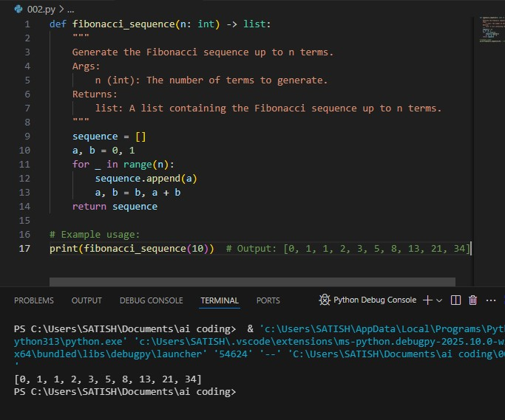

**Code Explanation:**

This function generates the Fibonacci sequence up to n terms:

Starts with a = 0, b = 1 (first two Fibonacci numbers).

In a loop, appends a to the list, then updates a, b to the next pair (b, a + b).

* Returns the list of n Fibonacci numbers.

Example:  
fibonacci_sequence(10) → [0, 1, 1, 2, 3, 5, 8, 13, 21, 34]

**03. PROMPT :**

Give me a python code to reverse a string

**CODE AND OUTPUT :**

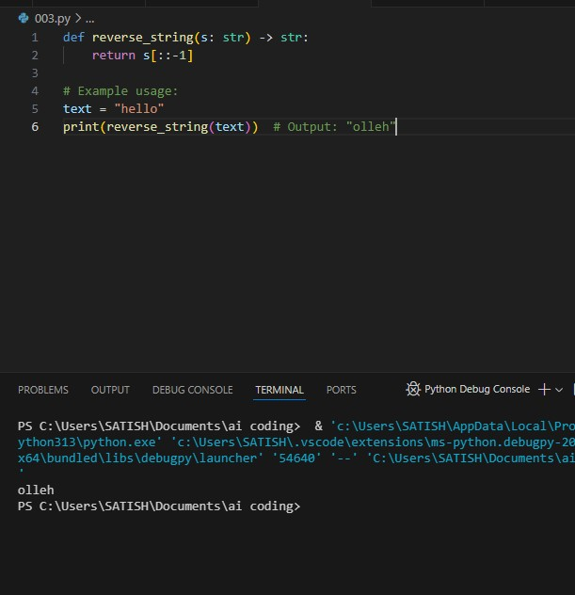

### Code Explanation:

This function returns the reverse of a given string:

* s[::-1] uses slicing to reverse the string.
* Example: "hello" becomes "olleh".

**04.PROMPT :**

i need a python code which works like basic calculator (add , substract, divide, mltiply ) and gives output

**CODE AND OUTPUT:**

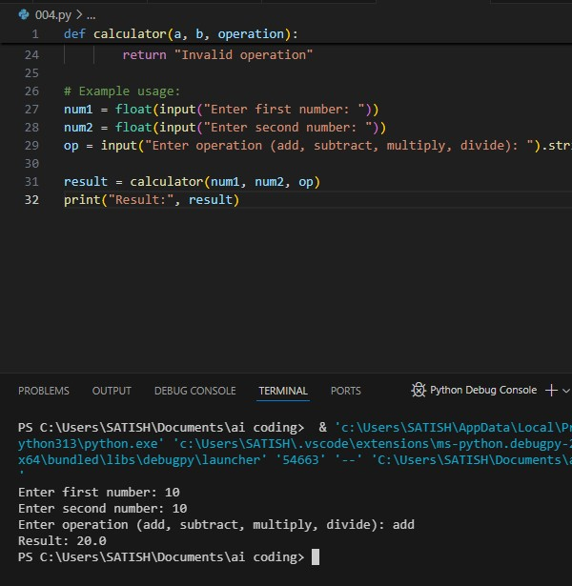

### Code Explanation:

This function performs basic arithmetic operations:

* Takes two numbers (a, b) and an operation (add, subtract, multiply, divide).
* Uses if-elif to choose the correct operation.
* Checks for division by zero.
* Returns the result or an error message for invalid input.

Example:  
If input is a = 5, b = 2, operation = 'add', output will be 7.

**05.PROMPT :**

i need a python code which reads a file and gives output number of lines

**CODE AND OUTPUT:**

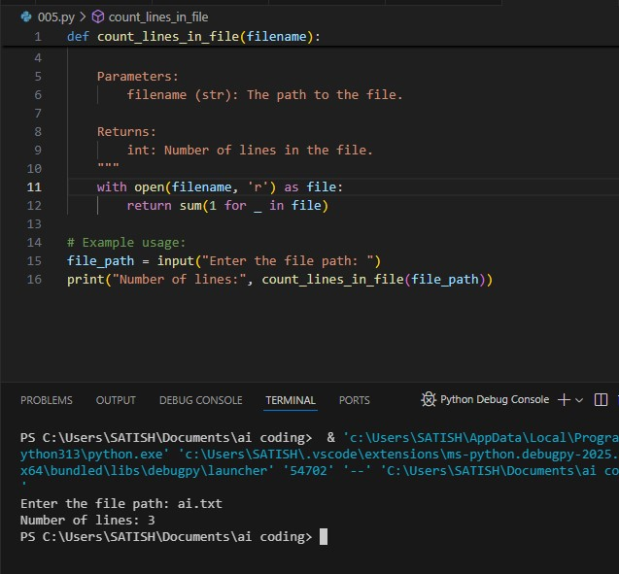

### Code Explanation:

This function counts the number of lines in a file:

* Opens the file in read mode.
* Uses a generator expression to count lines with sum(1 for _ in file).
* Returns the total line count.

Example:  
If a file has 10 lines, it will return 10.